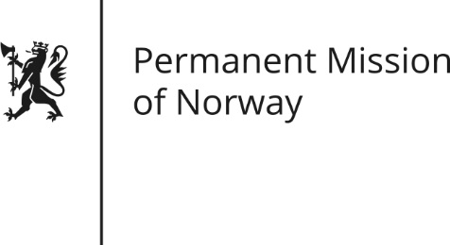

STATEMENT
Universal Periodic Review (UPR): ICELAND

by Ambassador Hans Brattskar, Permanent Representative

Tuesday 1 November 2016

Check against delivery

Mr. President,
Norway welcomes the delegation from Iceland and thanks the delegation for the presentation of their national report.
There have been significant improvements in Iceland since the last UPR-hearing in 2011, when Icelandic society was suffering from the consequences of the global financial crisis. Representing a welfare state, Icelandic authorities have through a targeted policy been able to improve the conditions for vulnerable groups, and they show decisiveness in moving further in this direction.
A rapidly growing economy, however, also brings new challenges. It brings more immigration, more human trafficking and could easily result in a larger unregulated labor marked, where the rights of workers are not fully respected. Norway therefore recommends increased focus on supervisory and control mechanism in the labor market. We would also encourage Iceland to develop a wider scope of protection against discrimination and more tools to address the rights of persons who are subject to human trafficking.
A rapidly improving economy also brings with it a need for the authorities have a comprehensive approach to tackling corruption and tax evasion, which in turn would benefit society and the overall enjoyment of human rights. Iceland is comparatively speaking faring well, compared with international standards. Nonetheless, Norway would, taking into account the rapidly expanding economy, recommend to improve financial supervisory mechanisms to ensure better control and transparency in order to combat corruption and tax evasion.

Thank you.

